**ScanBill Page Design**

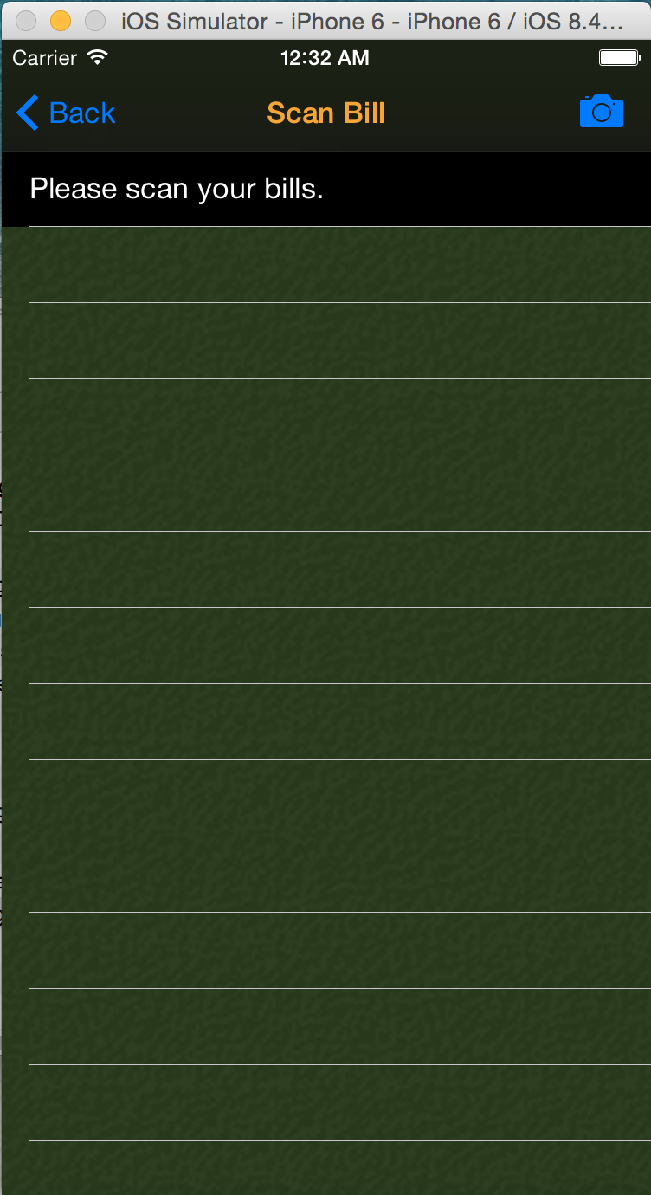**Elements:**

Title: “Scan Bill”, orange

Navigation left button: “Back”, blue; back to last page(menu)

Right bar button:

Camera style, click to scan codes

View Backgroud: image(dark green thyme)

Cells:

Orange background

ROW1:

Show Tips. Black background, white text

Other ROW:

Show “scan result”. Black text

before redeem, gray text after redeem

